Group Analysis in Dpabi for VBM results

Table of Contents

Part 3 Group Analysis for VBM results in DPABI 2

3.1. Two-sample t-test 2

Step 1 Sort data 2

Step 2 Two-sample t-test in Dpabi 2

3.2. Correlation Analysis 5

Step 1: Create directory 5

Step 2 ASD & nonASD files (with behavioral data) 5

Step 3 Correlation Analysis in Dpabi 6

Part 4 Dpabi: Viewer 10

4.1. GRF correction; Save mask; ROI signal extractor 10

Step 1 Choose outlay : Data_nonAD/foshan/CAT/VBM/GroupAnalysis/GM_CorrelationAnalysis/results/ASD/Gesell_Social/R.nii 10

Step 2 GRF correction 11

Step 4: Cluster report (View in Terminal) 13

Step 5 Save mask 14

Step 6: Utilities🡪ROI signal extractor 15

Step 7: Correlation analysis and scatterplot (mean GMV & Gesell_Social) in R studio 18

Part 5 BrainNet Viewer 19

Step1 Click ‘Load file’ 19

Step2 BrainNet_Option 20

# Part 3 Group Analysis for VBM results in DPABI

## 3.1. Two-sample t-test

* 这里都灰质分析为例，白质分析方法相同，除了复制的文件为smwp2*.nii 。

### 

### Step 1 Sort data

Create directories：

* cd foshan/CAT/VBM/GroupAnalysis/GM_t_test/
* mkdir ASD
* mkdir nonASD
* mkdir results

copy **smoothed** images (CAT/VBM/Preprocess/<subj_name>/mri/smwp1*.nii) into ASD or nonASD files，and name these .nii files with their own name. For example,

* cd CAT/VBM/Preprocess
* cp Jiangzhonghang/smwp1marage.nii ../GroupAnalysis/GM_t_test /ASD/Jiangzhonghang.nii

将所有被试的smwp1*.nii文件都复制、重命名。最后ASD和nonASD文件夹的里文件格式如下：

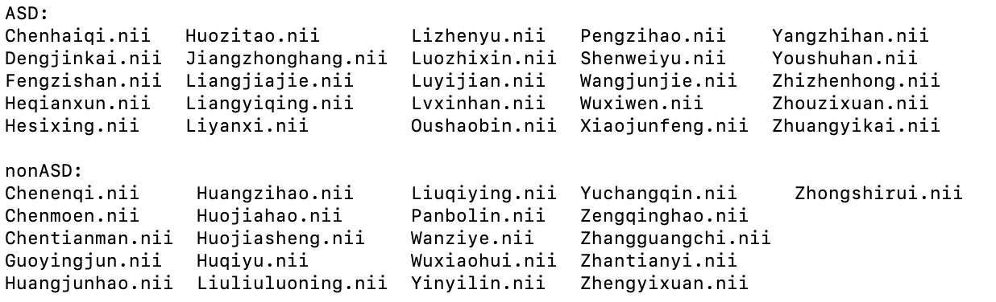

### Step 2 Two-sample t-test in Dpabi

1. **make text covariates files**

* cd GM_t_test
* gedit ASDtextcovariant.txt &
* gedit nonASDtextcovariant.txt &

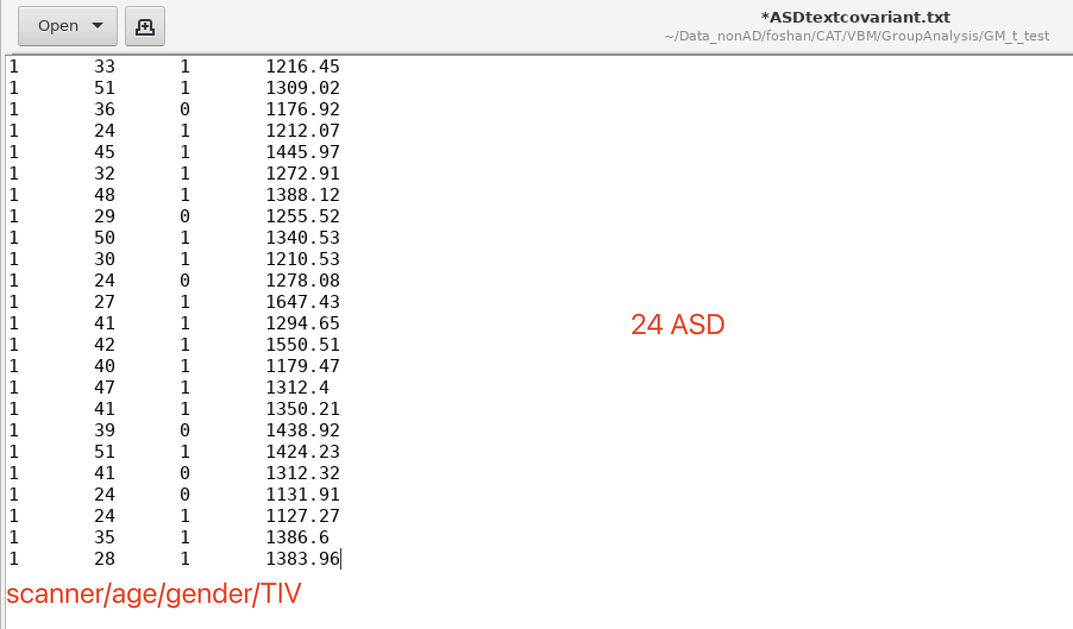

*each column represents one covariate.

*scanner, age, gender, TIV for each column above.

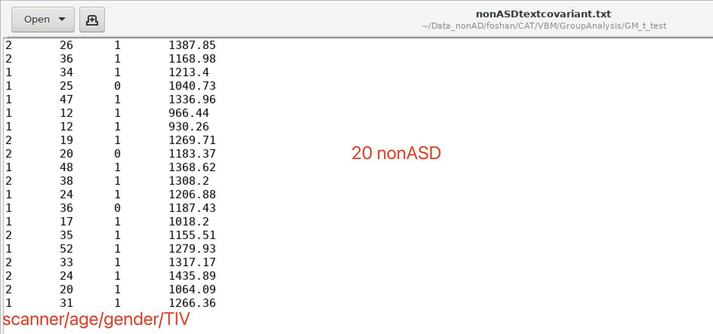

**2) two-sample t-test**

Step1：open dpabi， select ‘Statistical analysis’

Terminal input：

* matlab -nodesktop
* dpabi

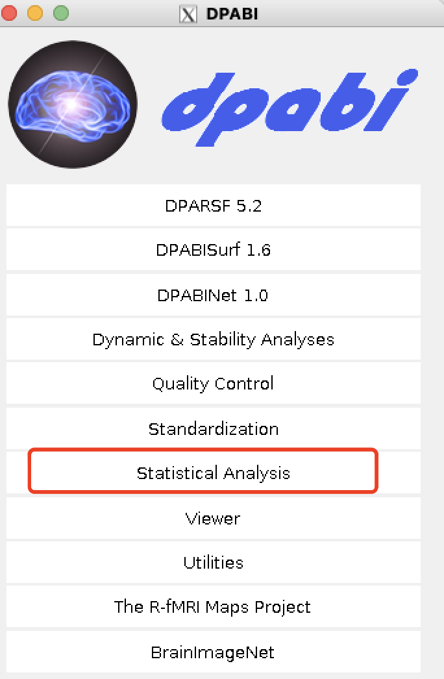

Click ‘Statistical Analysis’.

Then, in the new interface:

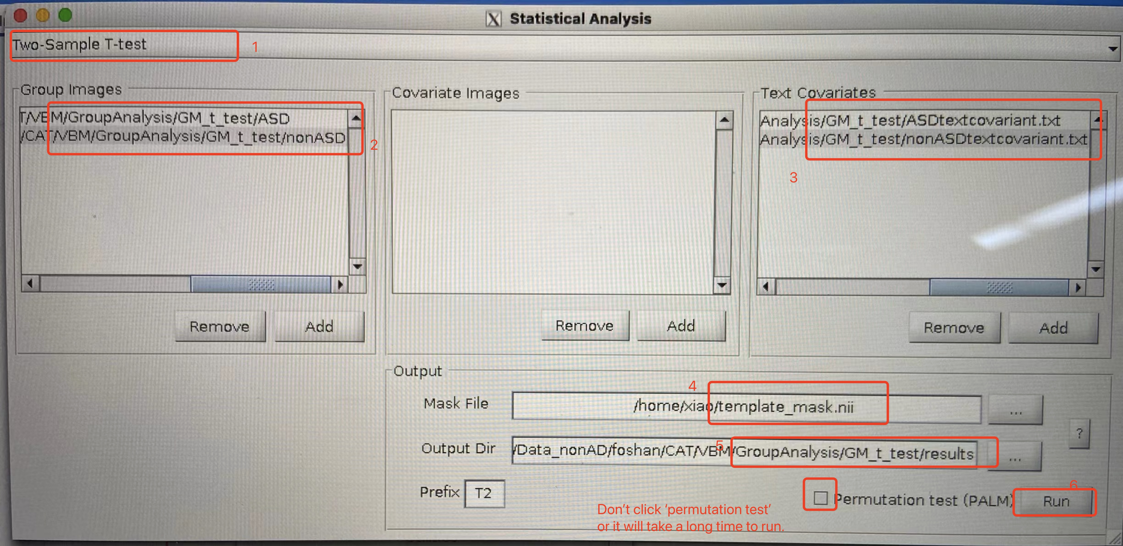

*Permutation test用时很长，即使是设1000次也要跑很久，可以不选。

**TIV_GM_WM_CSF_WMH.txt**

**Output files：(into results file)**

(without permutation test)

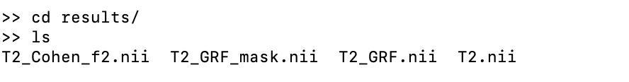

## 3.2. Correlation Analysis

### 

### Step 1: Create directory

Create directories：

* cd foshan/CAT/VBM/GroupAnalysis/GM_ CorrelationAnalysis /
* mkdir AllwGesell
* mkdir ASDwGesell
* mkdir nonASDwGesell
* mkdir covariates
  + 用来存放文本材料，如协变量。
* mkdir results
* mkdir results/ASD
* mkdir results/nonASD

results/ASD 和results/nonASD里需要各自建立子文件夹，用来存放不同维度的行为数据结果，比如：

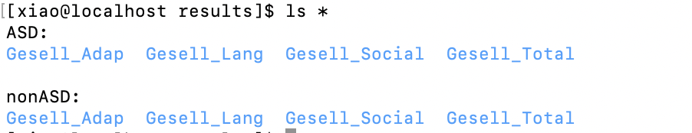

### Step 2 ASD & nonASD files (with behavioral data)

* 和t-test过程类似，但是只需要将有行为数据（比如Gesell）的被试的swmp1*.nii文件复制到一个文件夹里，没有行为数据的被试则不需要。
* tips: 可以复制t-test里的ASD 和nonASD文件夹，然后删掉不需要用到的被试。

copy smoothed images (CAT/VBM/*/mri/smwp1mprage.nii) into ASDwGesell，nonASDwGesell and AllwGesell files

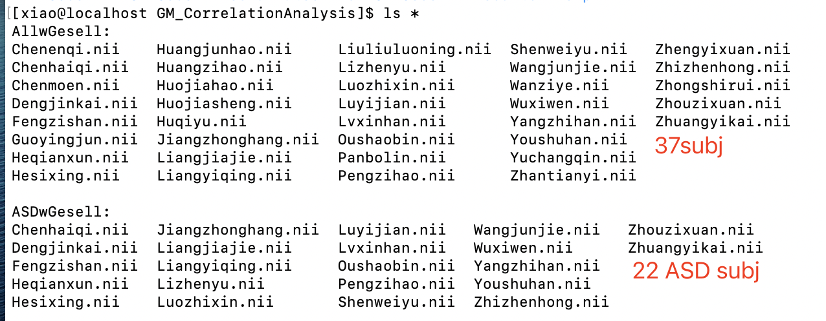

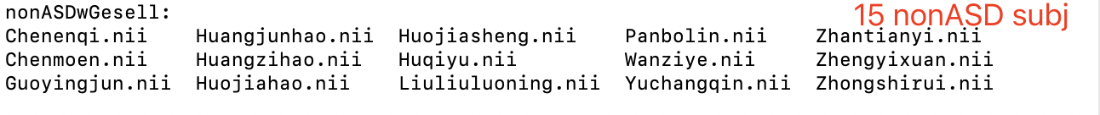

### Step 3 Correlation Analysis in Dpabi

**1）edit text covariates files (similar to that in t-test)**

**Tips：这些表格可以在本地电脑里创建一个Excel表格，存放在不同sheet里。**

**比如：**

**ASD**

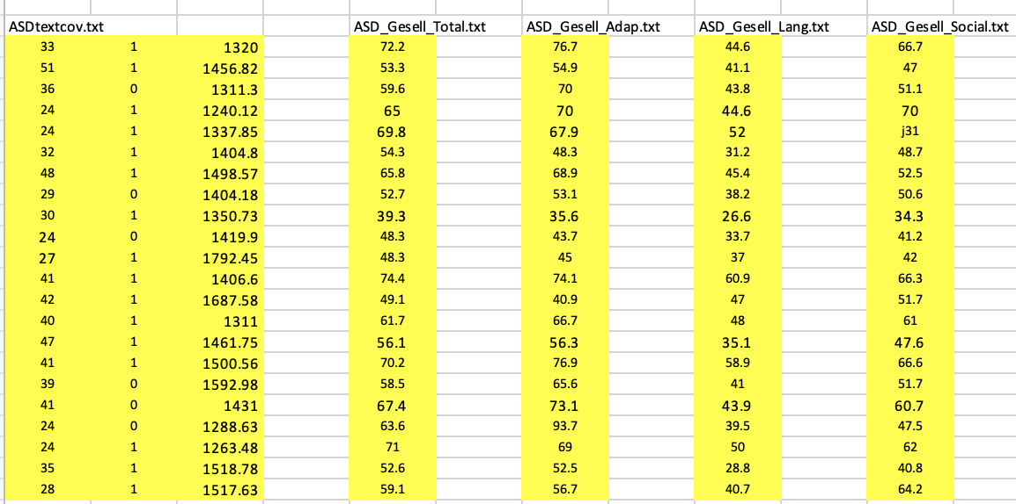

**nonASD**

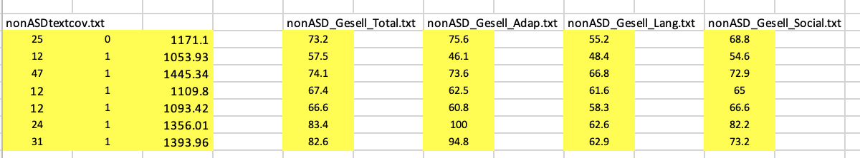

* cd covariates
* gedit ASDtextcov.txt &
  + 这里3列数据分别是：scanner, age, gender
  + 但是scanner都是1，所以删掉第一列，保留age gender就好

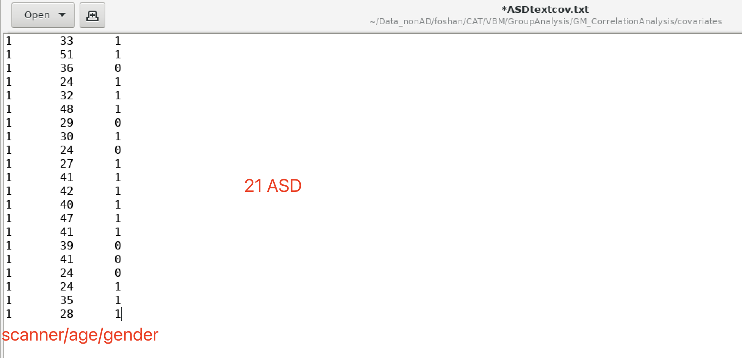

* gedit nonASDtextcov.txt &

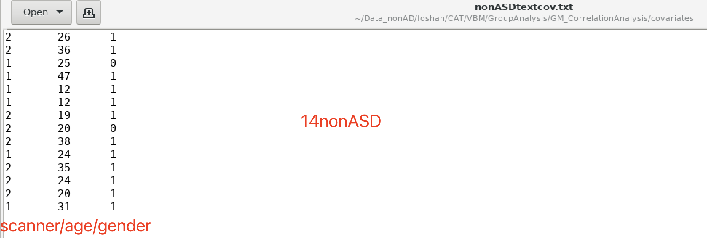

**2）Edit ‘Correlation seed series’ files**

（each file contains only one column, representing one behavioral variable）

Set up files for Gesell_total_score and each domains

Eg.

ASD_Gesell_Total.txt;

ASD_Gesell_Adap.txt;

ASD_Gesell_Social.txt;

ASD_Gesell_Lang.txt;

nonASD_Gesell_Total.txt;

nonASD_Gesell_Adap.txt;

nonASD_Gesell_Social.txt;

nonASD_Gesell_Lang.txt;

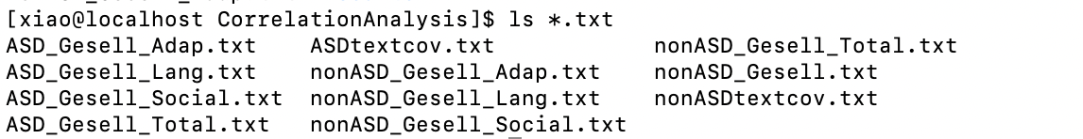

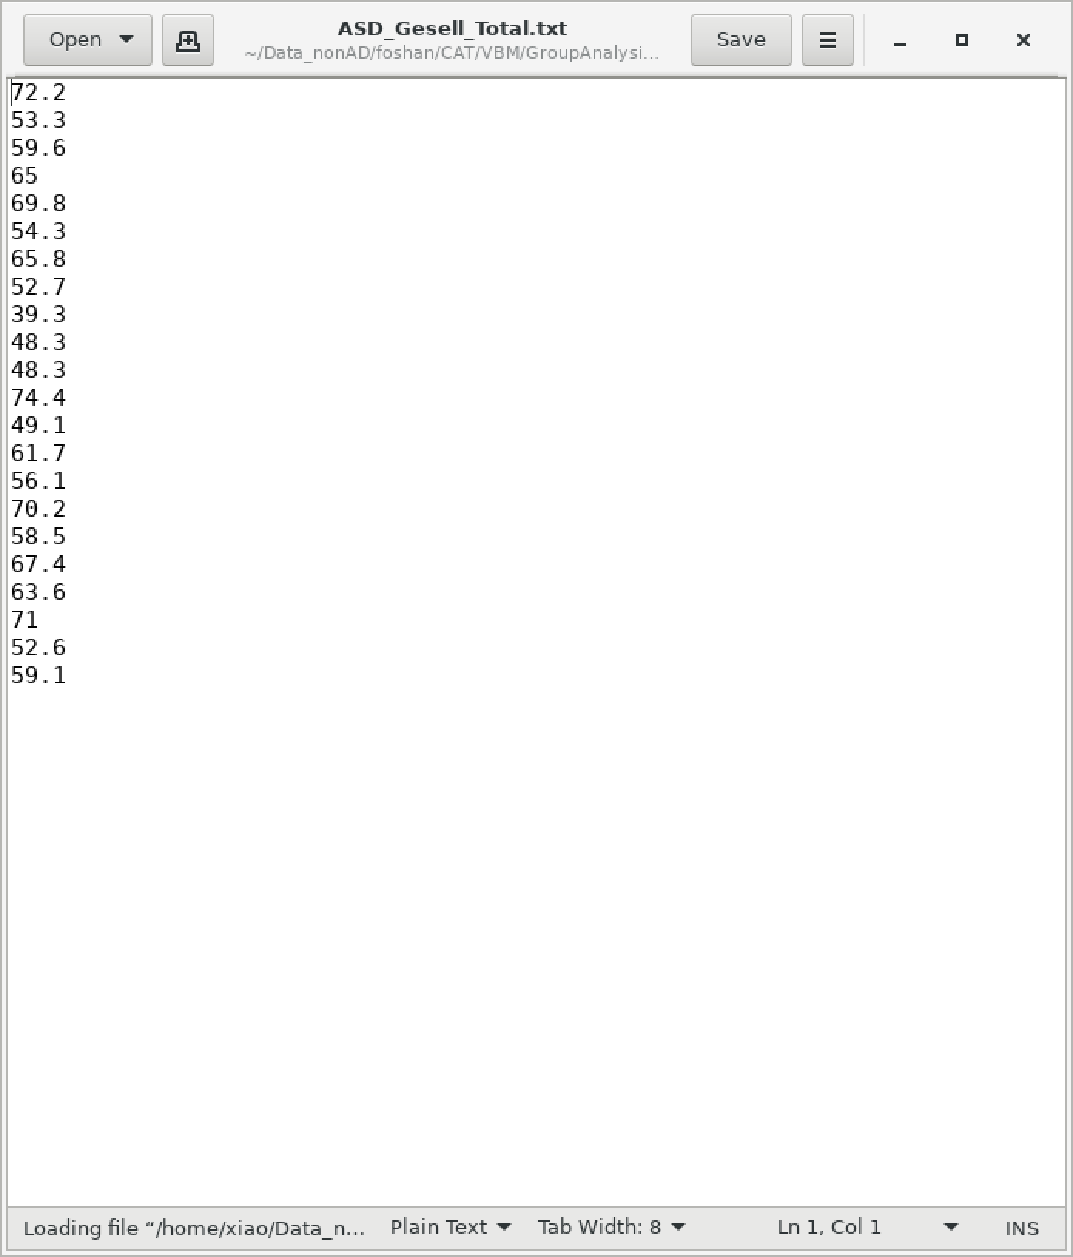

1. **Open dpabi，select ‘Correlation analysis’：**

* **Matlab -nodesktop**
* **Dpabi**
* **Statistical Analysis**

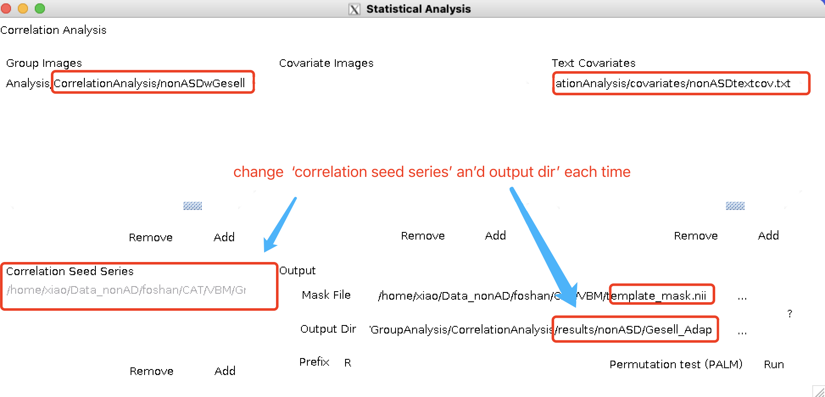

(permutation test 不选)

# Part 4 Dpabi: Viewer

## 4.1. GRF correction; Save mask; ROI signal extractor

> dpabi

> click ‘Viewer’

8 R.nii file:

|  |  |
| --- | --- |
| ASD;  nonASD | Gesell_Adap |
| Gesell_Lang |
| Gesell_Social |
| Gesell_Total |

Take ASD Gesell_Social/R.nii for example. Then repeat the same process for other 7 R.nii files.

### 

### Step 1 Choose outlay : Data_nonAD/foshan/CAT/VBM/GroupAnalysis/GM_CorrelationAnalysis/results/ASD/Gesell_Social/R.nii

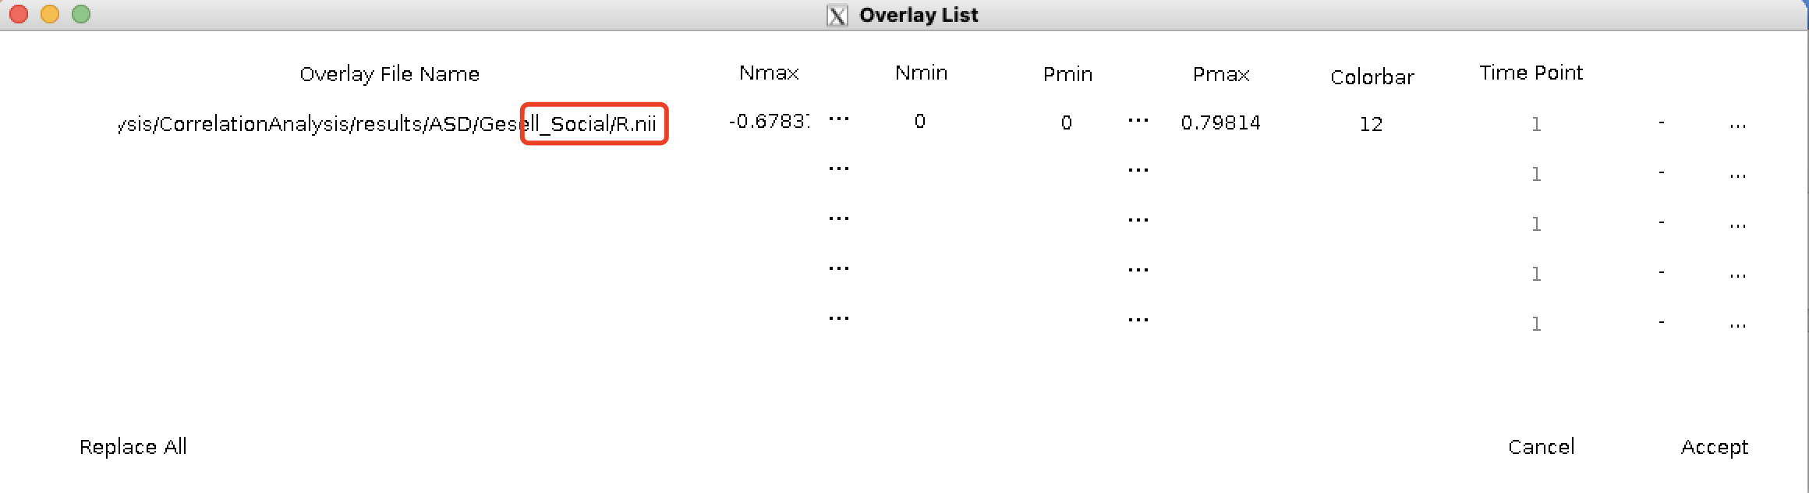

### Step 2 GRF correction

ASD df = 19

nonASD df = 12

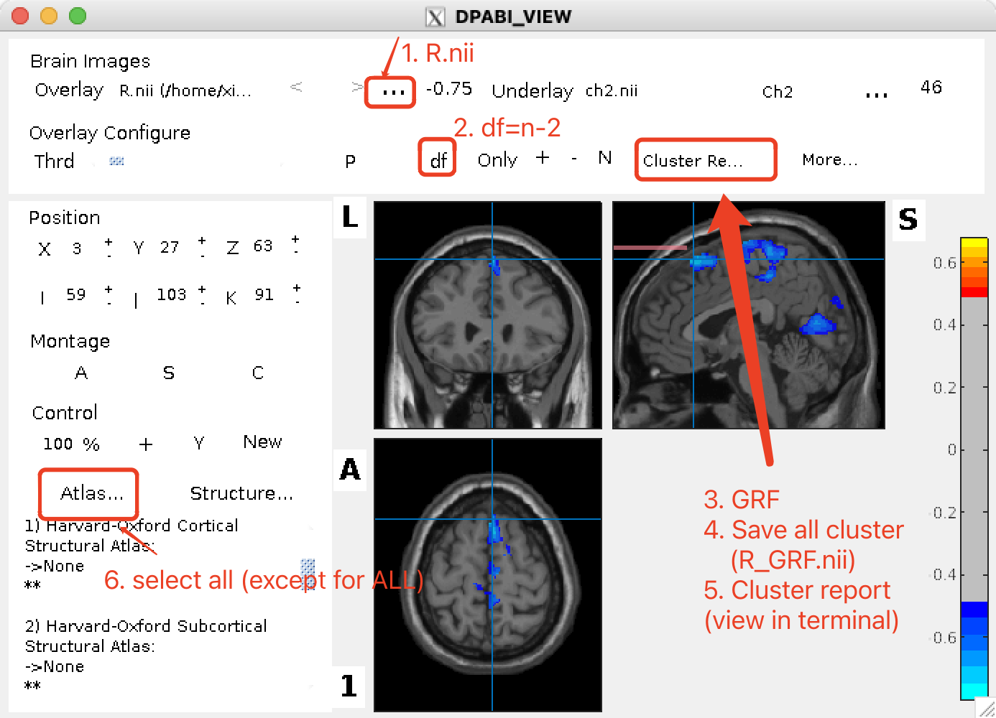

GRF correction

Mask file: home/xiao/Reslice_template_mask.nii

Voxel p value 0.0214

Cluster p value 0.05

Two-tailed

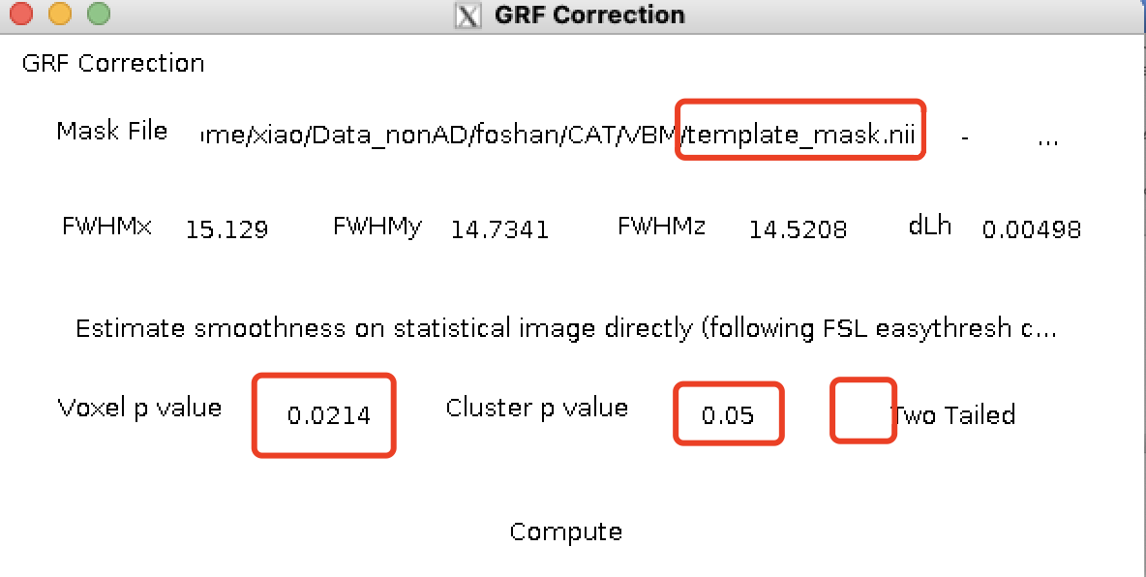

Step 3: Find peak in this cluster

1. Select Atlas: select all
2. Find peak
3. Screenshot

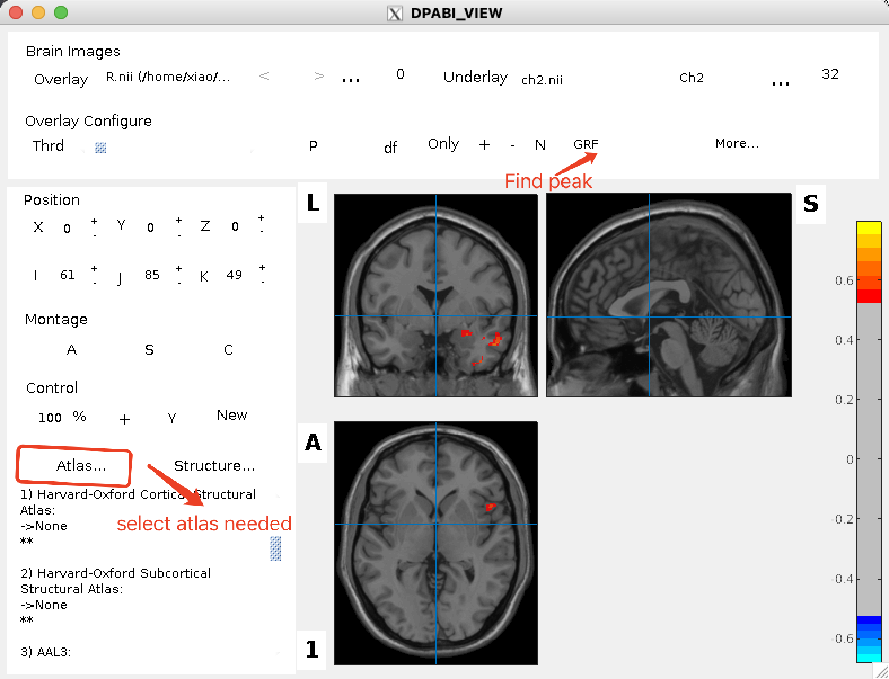

### Step 4: Cluster report (View in Terminal)

1. Cluster report
2. Copy the report from ‘Terminal’ into a text file.

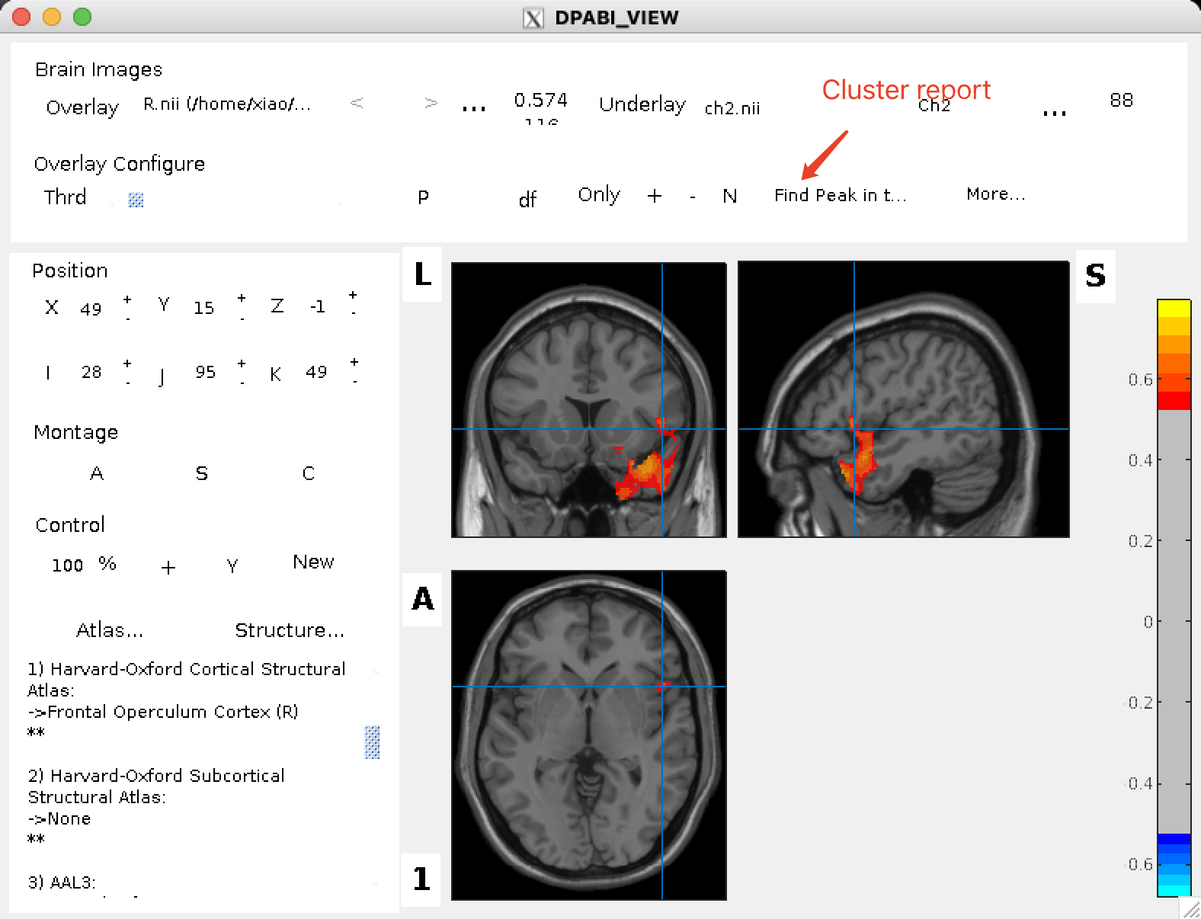

### Step 5 Save mask

1. save all cluster (name it as ‘R_GRF.nii’)

And then you will see an ‘R_GRF_mask.nii’ file in the same directory.

This is the mask to be used in extract ROI and time series.

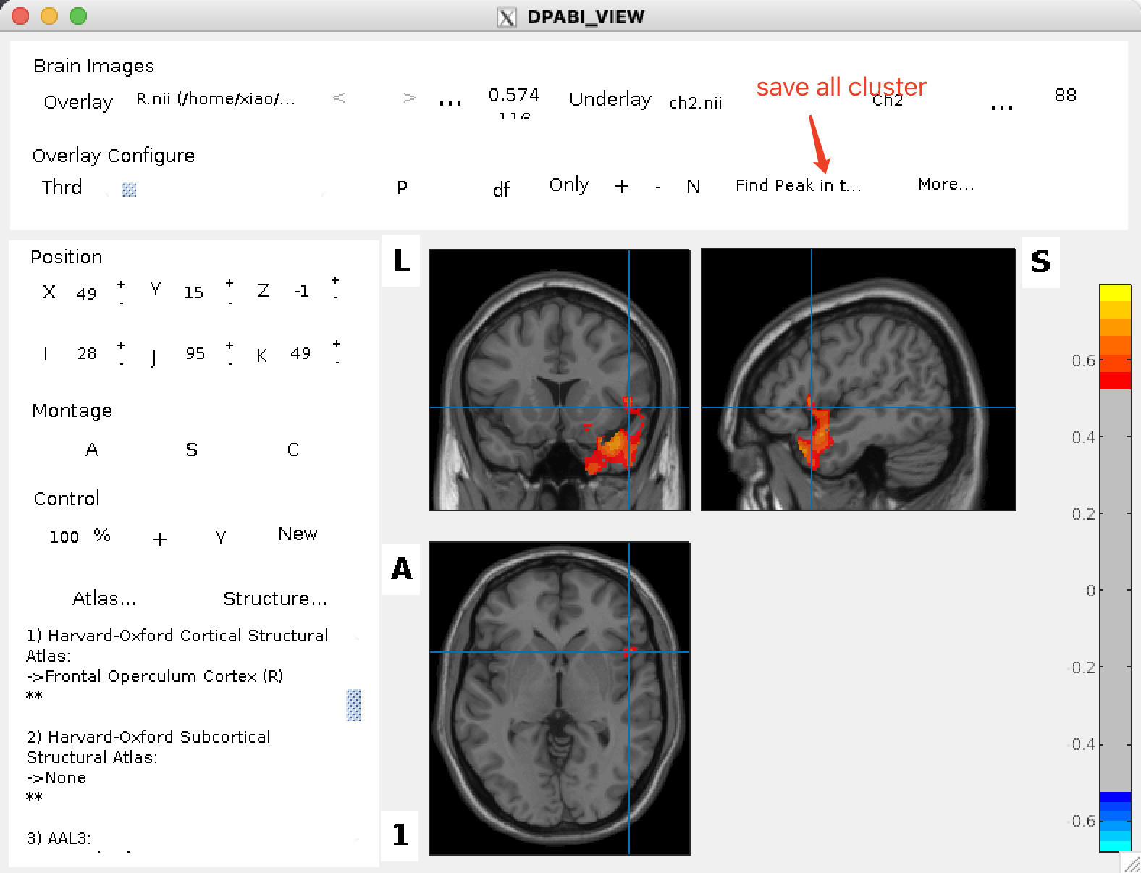

### Step 6: Utilities🡪ROI signal extractor

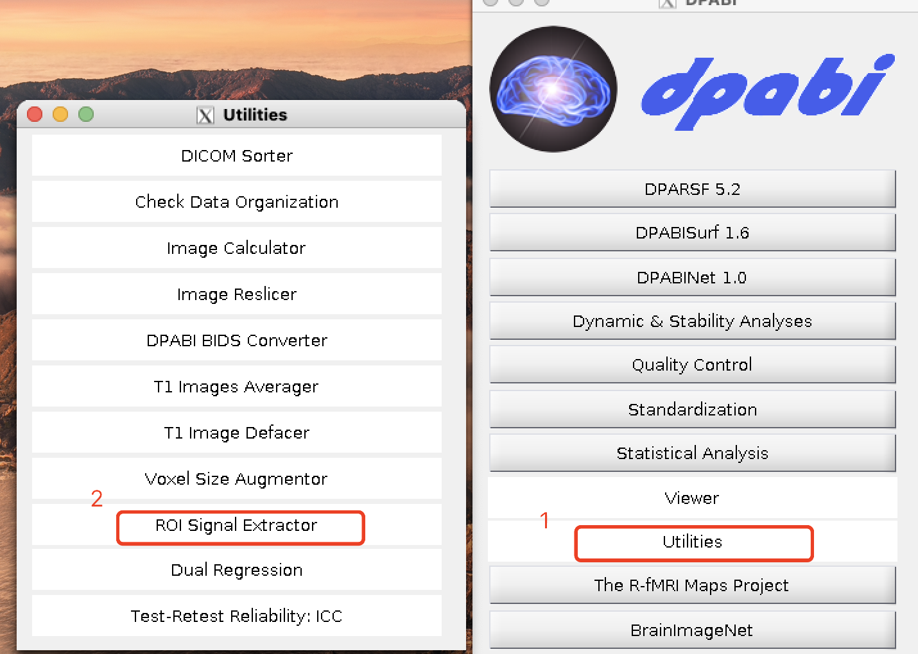

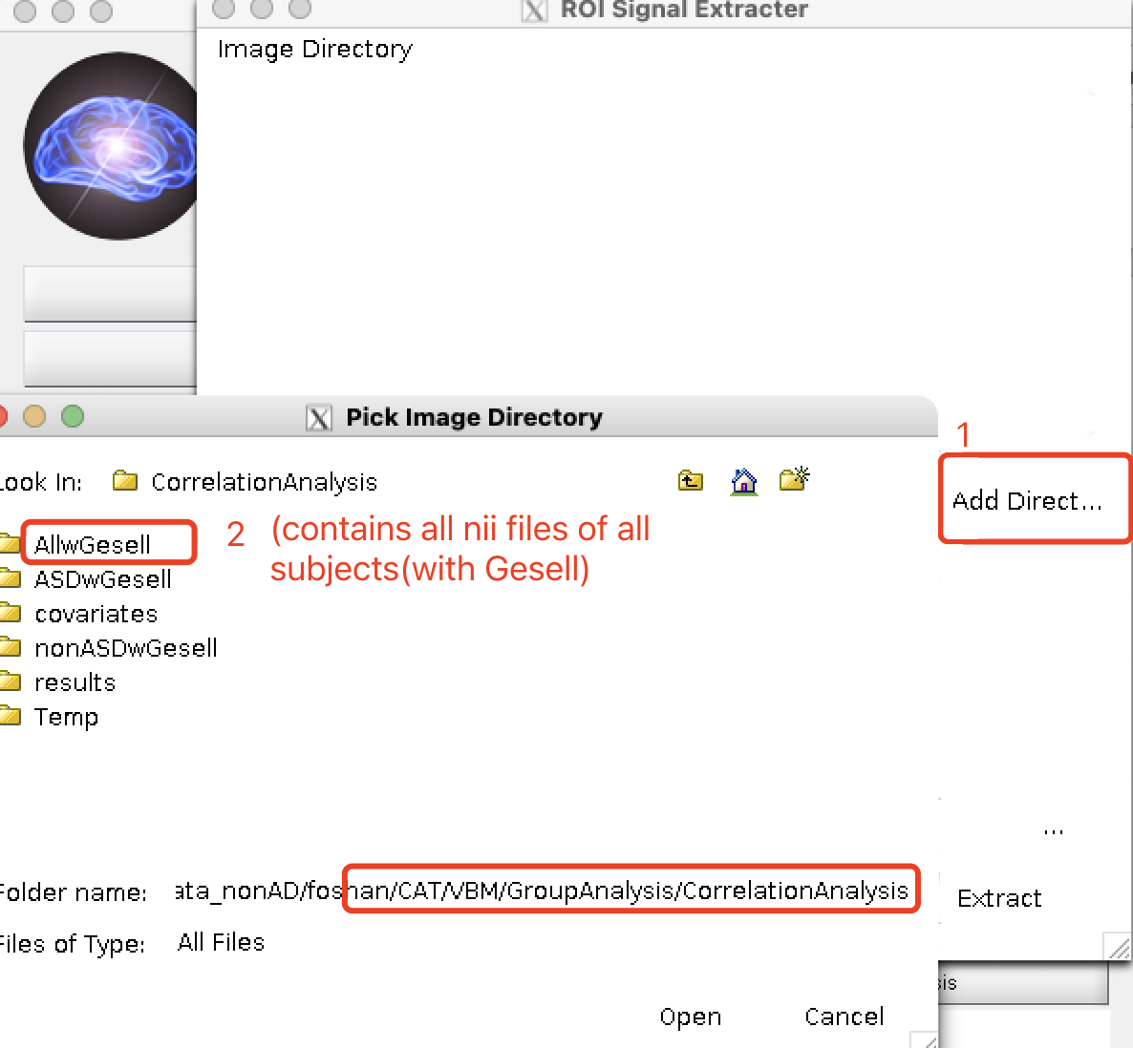

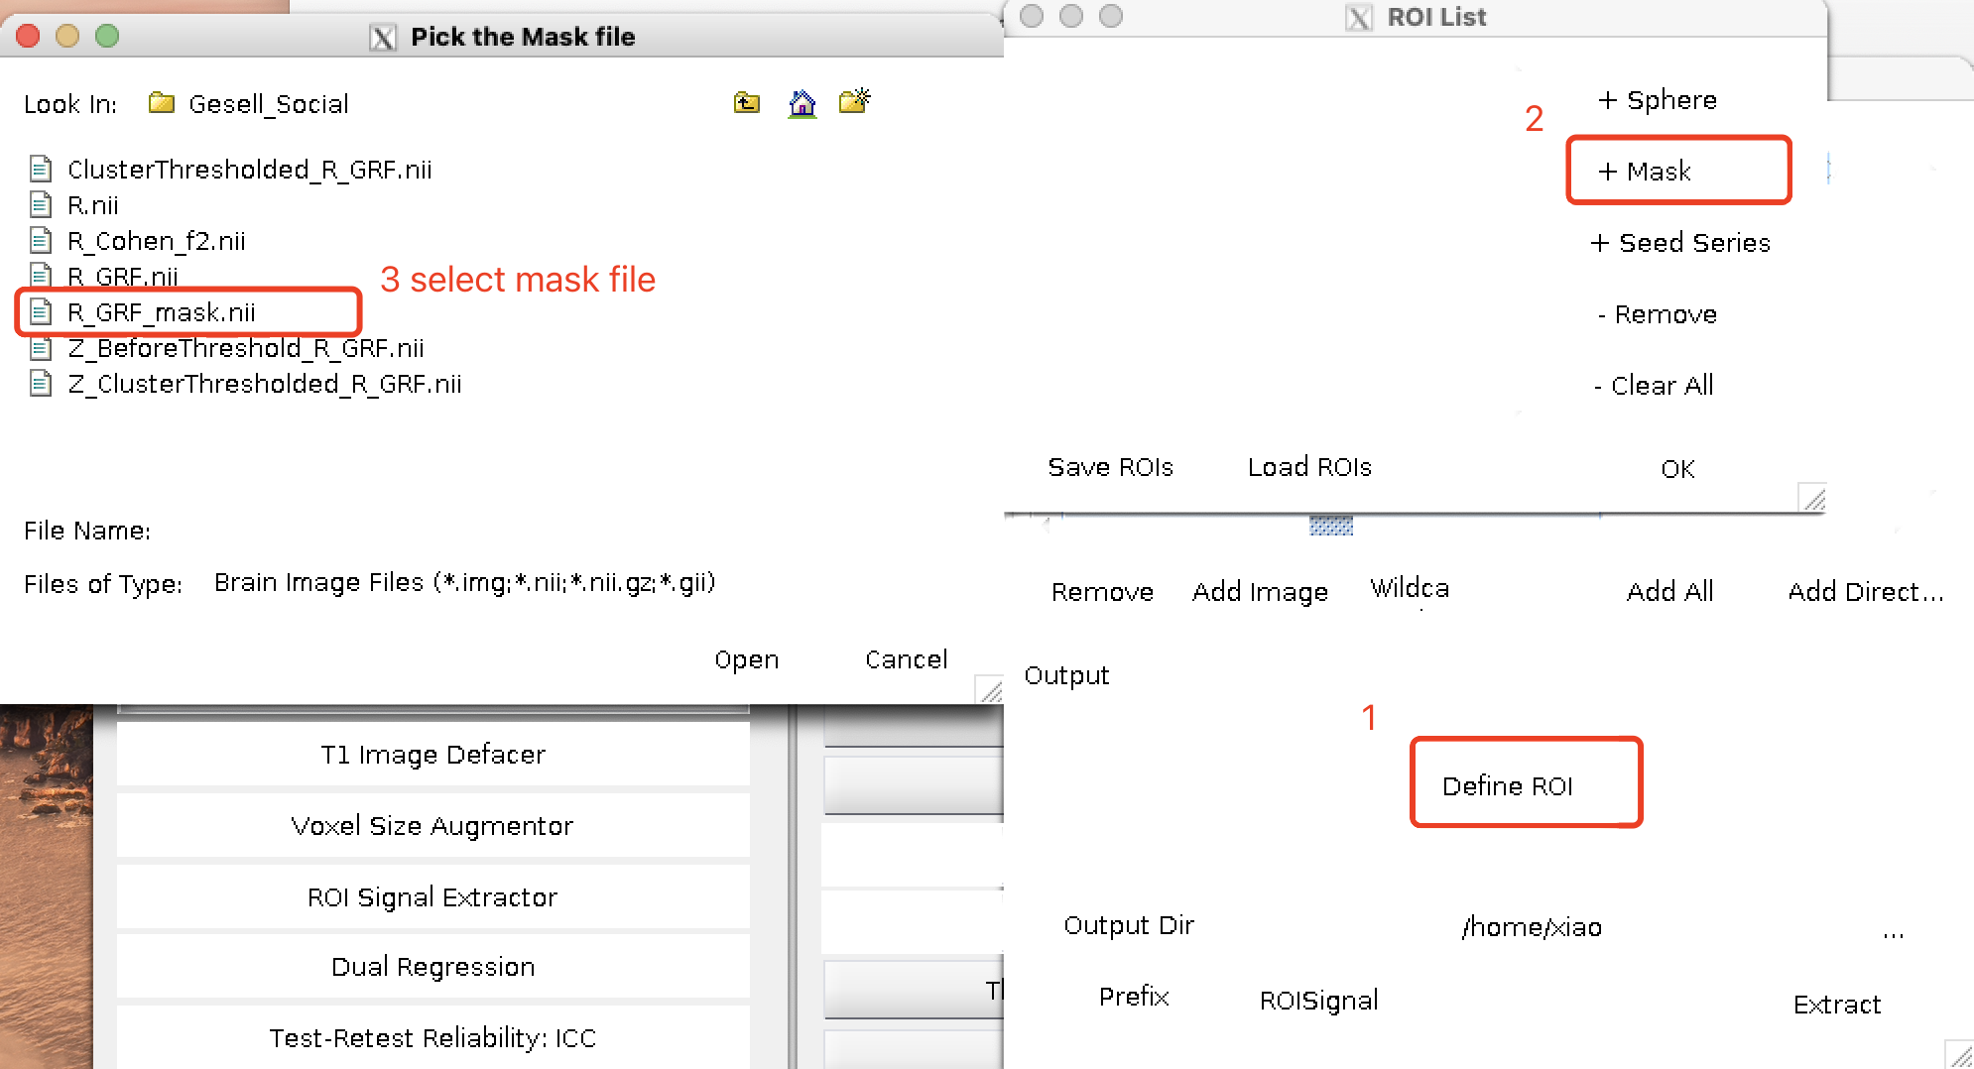

* Mask 是GroupAnalysis/GM_CorrelationAnalysis/results/ASD/Gesell_Social/里的 R_GRF_mask.nii

选择保存路径：

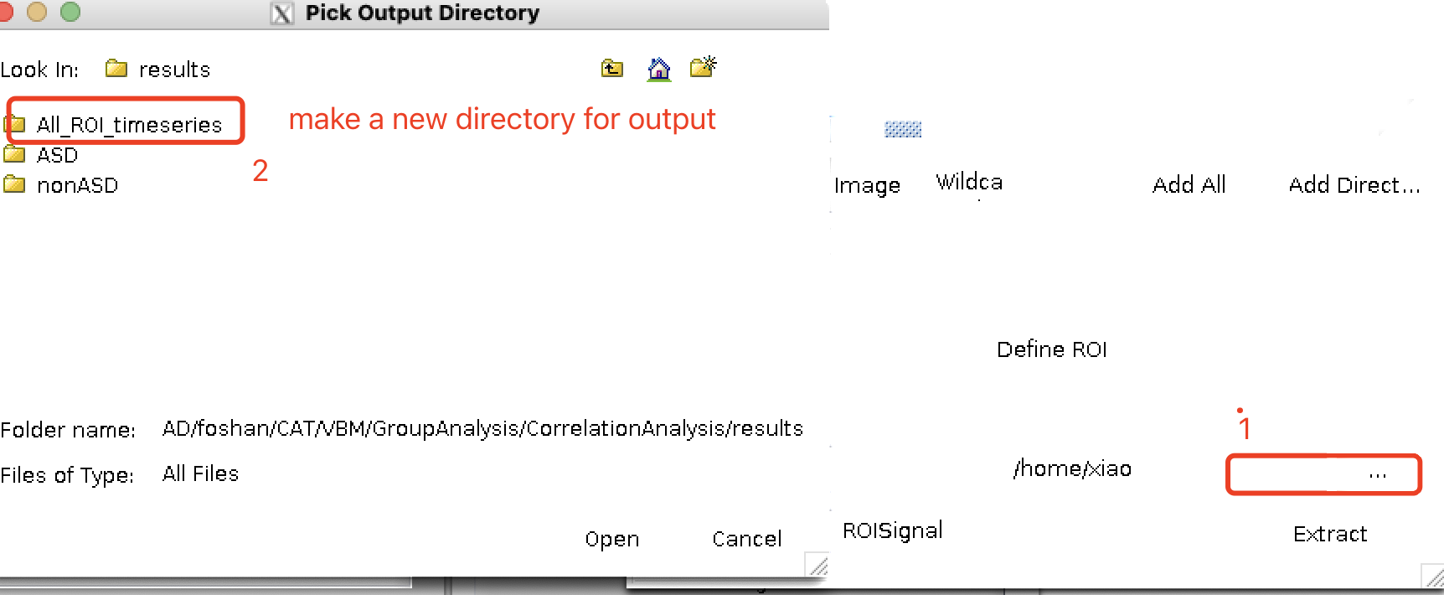

Click ‘Extract’, then see the results (**ROISignals_ROISignal_AllwGesell.txt**) in Terminal (i.e. Gray matter of all subjects)

### Step 7: Correlation analysis and scatterplot (mean GMV & Gesell_Social) in R studio

更新group2.xlsx 里的GMV 表单的内容。

打开脚本：Documents/foshan/stats_analysis/scripts/cor_GMV_Social(VBM).R

输出相关分析、回归分析、偏相关分析的结果和散点图。

# Part 5 BrainNet Viewer

>> matlab -nodesktop

>> cd AD_Project/soft_temp/BrainNetViewer_20191031/

>> BrainNet

Only nonASD group

### Step1 Click ‘Load file’

on the left-up conner

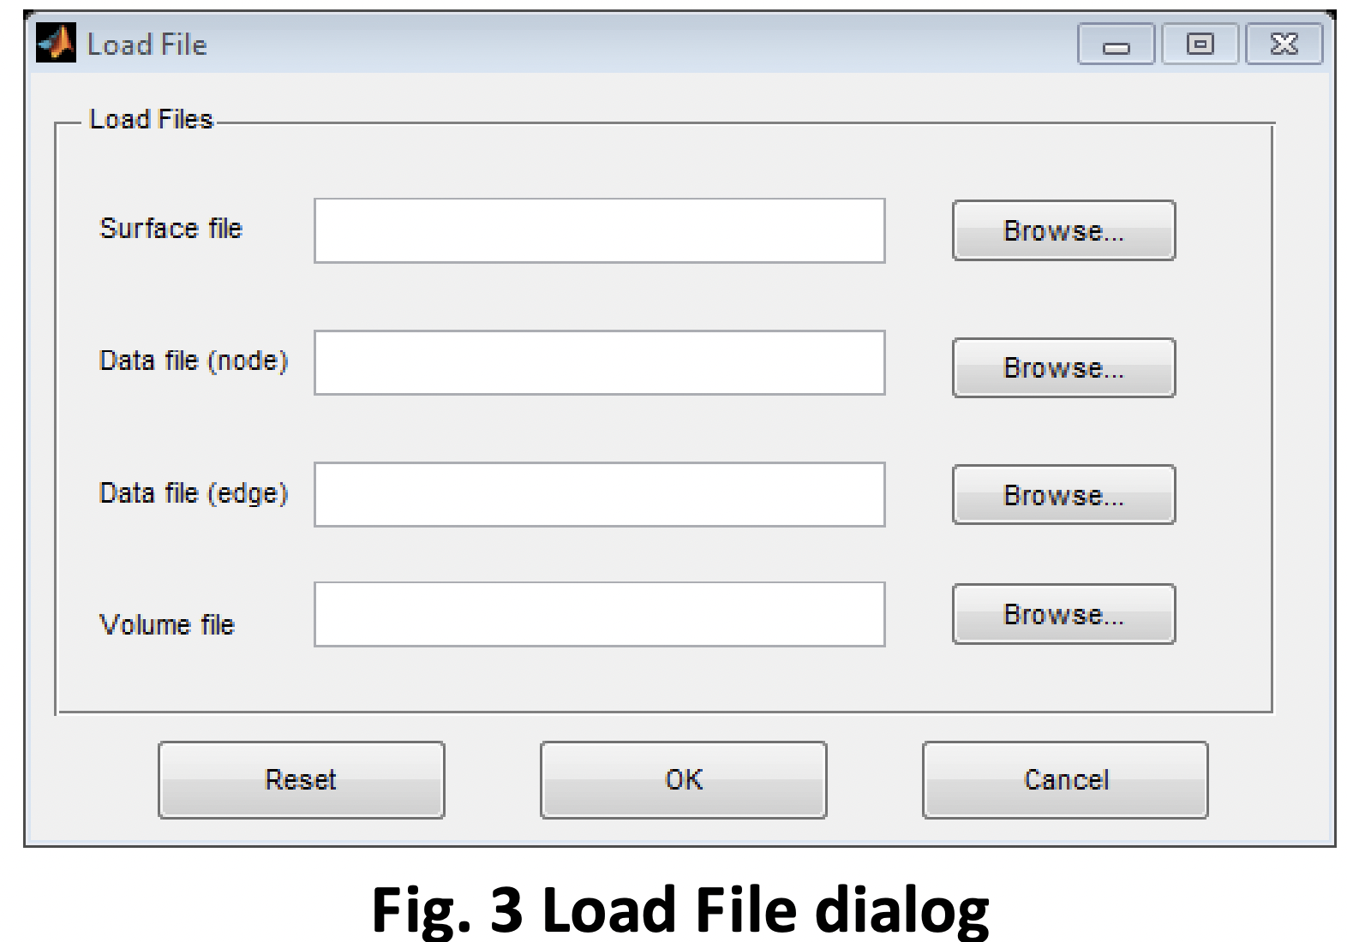

Load Image:

1）Surface: BrainMesh_ICBM152_smoothed.nv as surface

Leave alone the 2nd and 3rd files

4）Mapping(Volume file): GM_CorrelationAnalysis/results/nonASD/Gesell_Lang/Z_ClusterThresholded_R_GRF.nii

### Step2 BrainNet_Option

1） Layout (as ‘results_for_paper’ page 9)

2）Volume

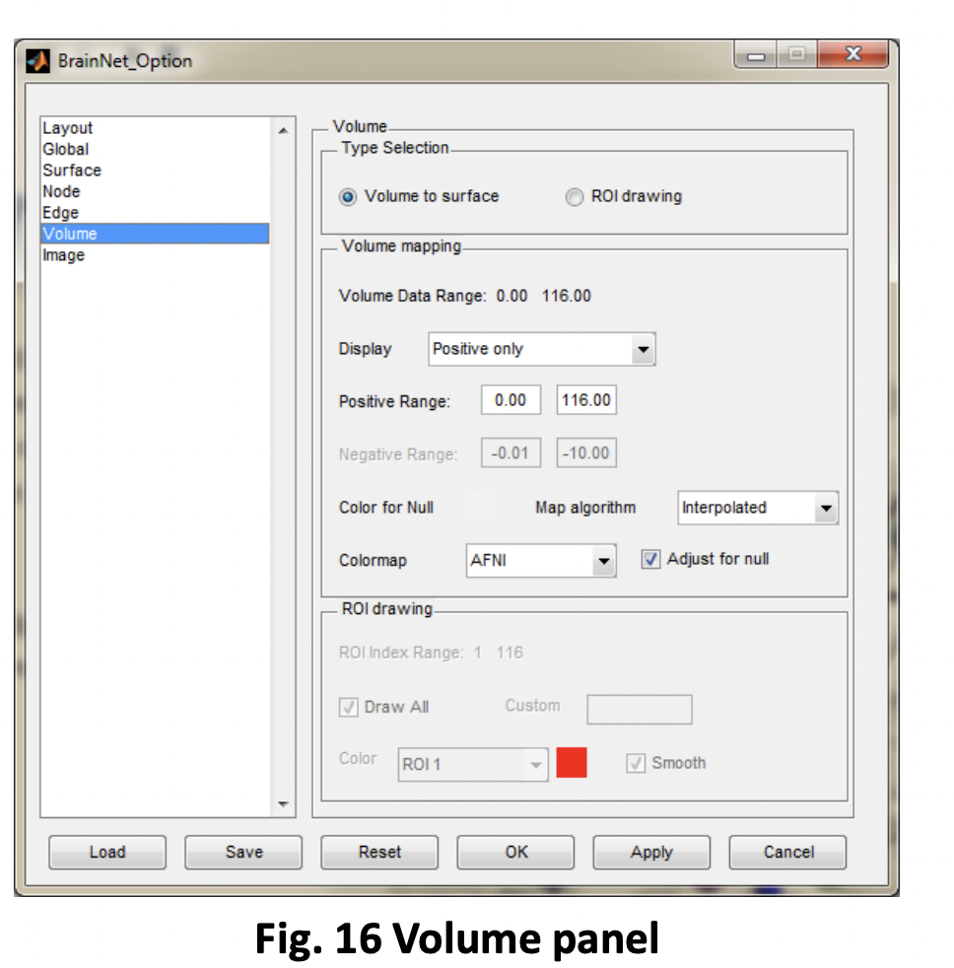

* Display: positive only;（2.3～4.7 ; 不同唯独（Adap/Social/Lang/Total）colorbar的范围要一样，比如都是2.3-4.7）
* Map: Nearest voxel;
* colomap AFNI_pos

》 click ‘OK’， then put the results into ppt ‘results_for_paper’ page 9